This dashboard is made for visualizing the performance of Inbound Net Service Level (NSL) weekly, analyzing the root cause of failures and finding the solutions to improve Net Service Level.

There are 5 pages in this report:

1. Scorecard:

Provide the available NSL number for Operations Excellence Manager and Operations Specialist to fill in the slides easily

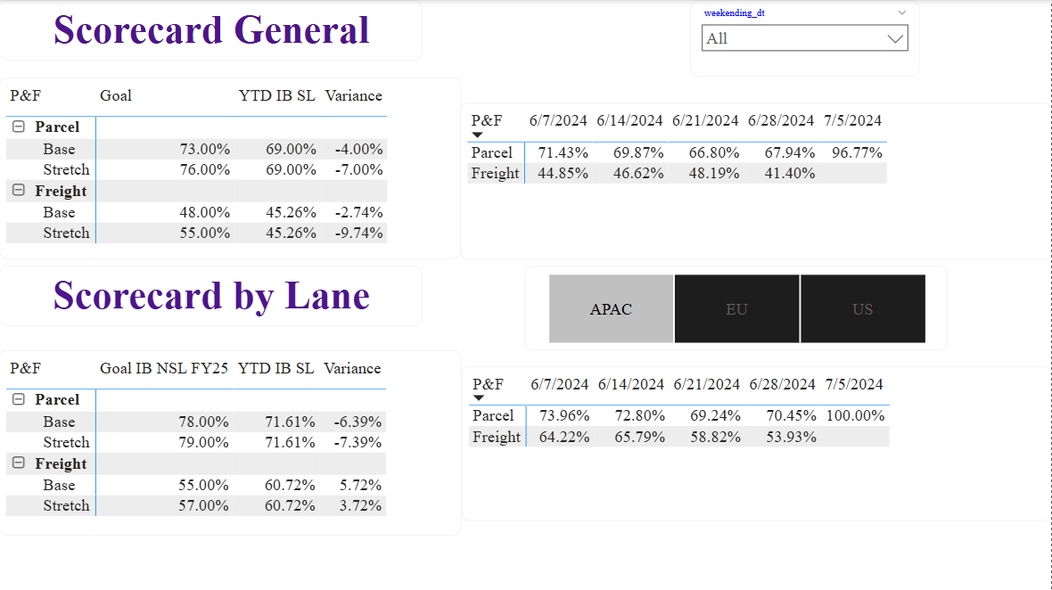

1. Inbound (general): Provide the general NSL for the whole week/month and overall failure buckets happened each week divided by Parcel and Freight service

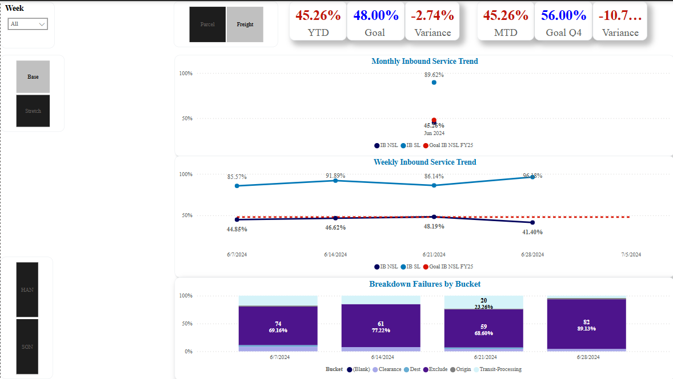

1. Inbound (Lane): Provide the detailed NSL for each week, failure buckets, top category causes and top fail location divided by Parcel and Freight service and by lane APAC, EU, US

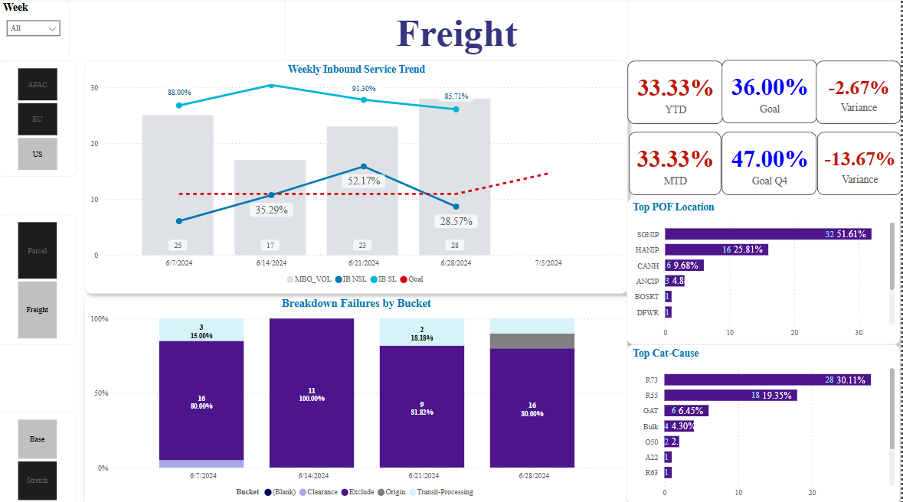

1. Pivot table: Analyze the trend of NSL and volume each week

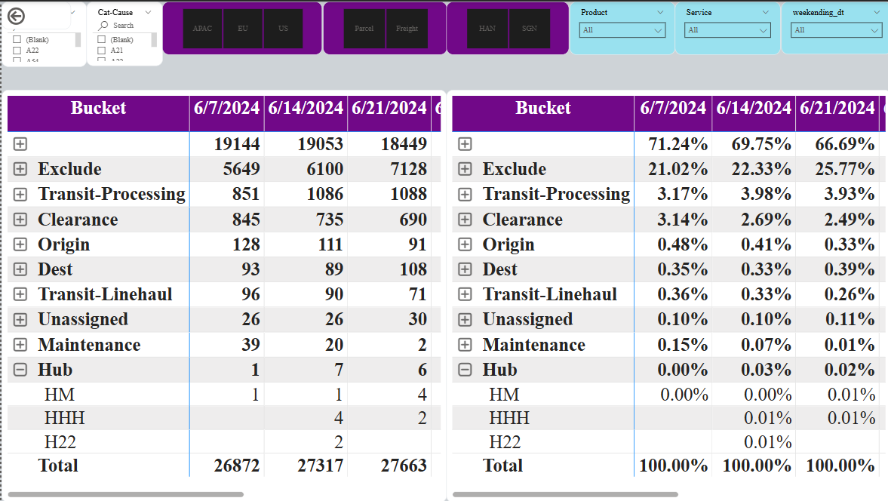

1. Deep dive: Analyze the trend of each category causes monthly, weekly and daily. Knowing the top failures by origin airports, countries, top fail locations, top fail services, top fail destination location id

